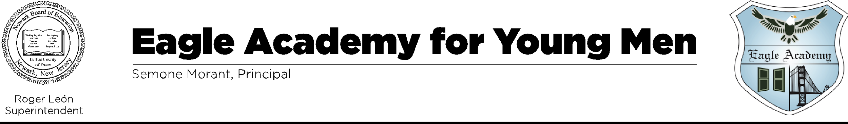
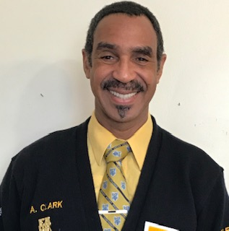

September 1, 2023

Hello,

I am Angelo Clark, your Parent Liaison at Eagle Academy for Young Men of Newark. Welcome to the 2023-2024 school year! Here at Eagle Academy, we have a Parent Teachers Organization. Our organization has been put in place by the Board of Education, to assist Parents/Guardians, with our; schools’ processes, documents, portals, and learning workshops. I am a Newark native and educated by the Newark Public School System. After attending Virginia State University, Petersburg, VA, receiving a Bachelor of Science degree in Business Administration, I returned to Newark and was employed by the Newark Public School system for 35 years as a substitute teacher and track & field coach. For the three years, I have operated as the Parent Liaison at Eagle Academy for Young Men of Newark.

To serve you efficiently, we ask that you visit our school’s website, Eagle Newark.com. On Our Website, you will find our School Parent Portal, Lunch Applications, Google Classroom, current information, Town Hall meetings and our main office support helpline. Also, you will be able to find our parent BitMoji room, here you will be able to access your, School Parental Involvement Policy, Right to Know Letter and Home School Compact Brochure, lunch applications, and other resources I would like all Parents/Guardians to participate in all of our meetings in order to continue to assist our scholars in every way possible. I can be reached at,

Angelo N. Clark - Parent Liaison
Eagle Academy for Young Men of Newark
279 Chancellor Avenue
Newark, N.J. 07112

Phone: 973-705-3849 or 973-705-3847
Email Address: a1clark@nps.k12.nj.us

Thank you,

Angelo N. Clark

